Questions and bugs from 2.4.26 and 3/5/26 testing

- What’s the Leader column in the spreadsheet view for Group Upload?
- Assignment email template needs minor wording tweaks and removal of extra white space so it matches the desired screenshot design.
- 360 module currently cannot assign multiple assessments to a single participant; this must be enabled and fixed. This limited my testing.
- Response styling needs an updated design (phase 4) to match the preferred, more polished layout shown in the reference screenshot.
- Deprecated/unused profile element under member profile was supposed to be deleted but is still visible; confirm whether it is needed and remove if not.
- Workflow after survey responses are complete is unclear; need defined steps and UX for what happens when responses are finished.
- Need ability to edit assignments for a survey (extend deadlines, delete assignments, etc.), similar to the edit options available on the referenced page.
- For the bulk-report feature, status/readiness is unclear; need a way to know when reports are ready and ideally download them as a zipped folder rather than individually.
- There is still an unresolved issue preventing adding a specific person as a rater for a given rating, likely due to not being able to assign multiple assessments to a single person in 360.
- Deleting assessments is not currently possible and must be implemented.
Below are screenshots and more detail to support these bullets

Yellow highlight known bug/issue’ Green highlight, new

- What does column ‘Leader’ mean? – Still don’t know.

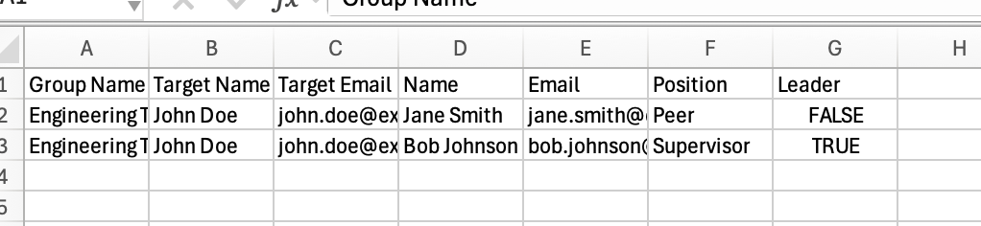

Email template for assignments: - Still needs a bit of tweaking.
Hello [name],

You have been assigned the following assessment(s):
[Assessment name(s) with link]

Please click the link above to open the dashboard and log in. Please complete your assignments by [date].
- If the link doesn’t work, copy and paste the link at the bottom of this email into your web browser.

You can access your assignments at any time from your dashboard (link).

SAVE this email and BOOKMARK your login page. If you have been assigned multiple assessments, this will help you navigate to the login page.

If you have any questions, please contact us at: support@involvedtalent.com

Thank you!

-Involved Talent Team
© 2026 Involved Talent

Direct Link to Copy and Paste: {LINK}

COMPARE TO SCREENSHOT BELOW – Will forward you email I received so you can see it live.
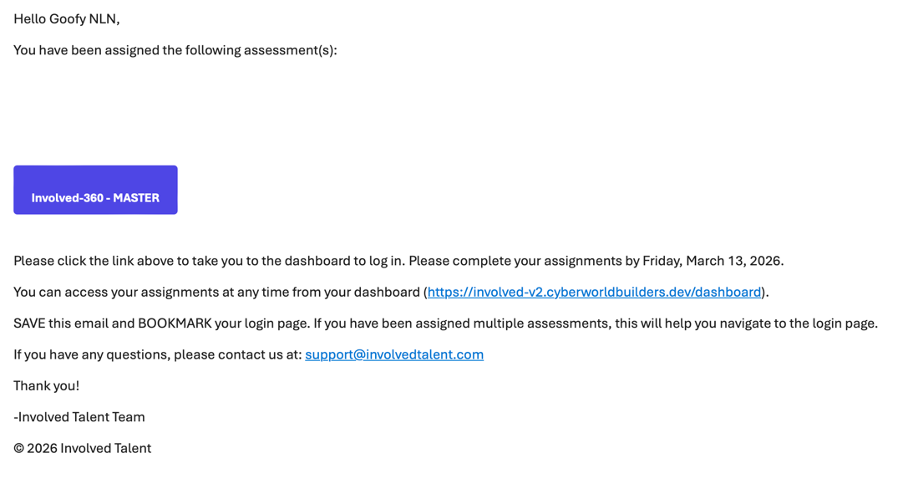
Remove this white space

Can’t assign multiple assessments for 360s – this has to be fixed. See screen shot below and video is slack
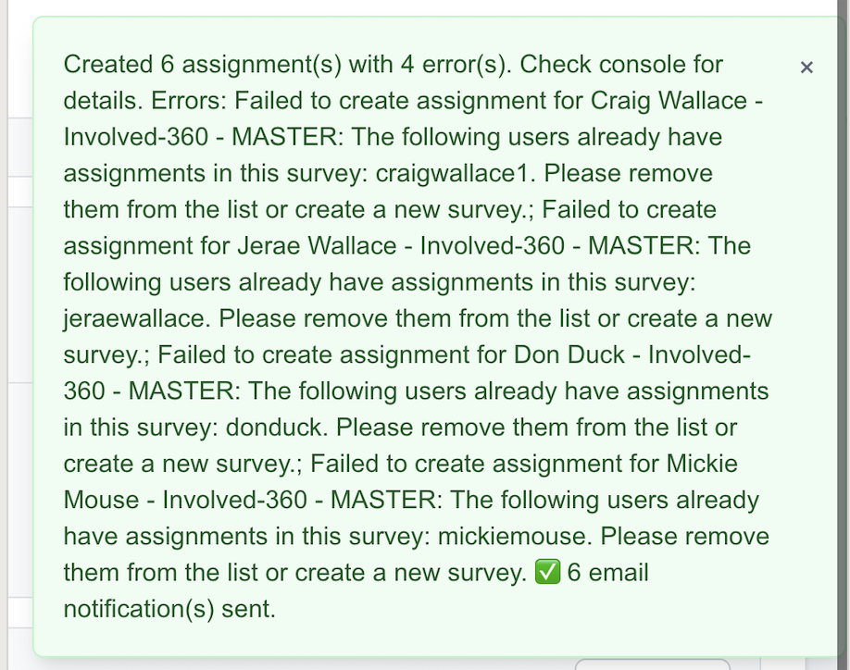

Styling for responses – can be phase 4: Time to do this
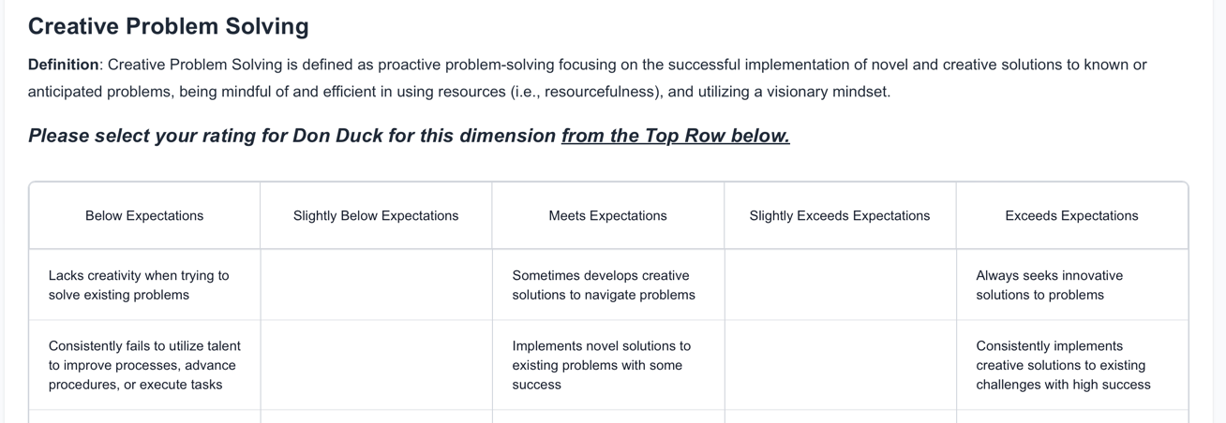
MORE LIKE THIS: (below)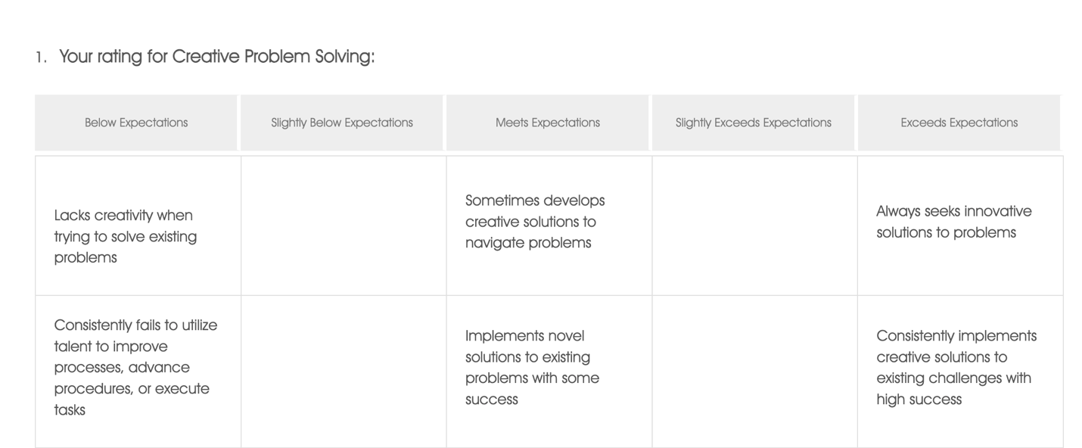

Why is this still there? Supposed to be deleted. Under profile when logged in as member. DO WE NEED THIS FOR ANYTHING? STILL THERE
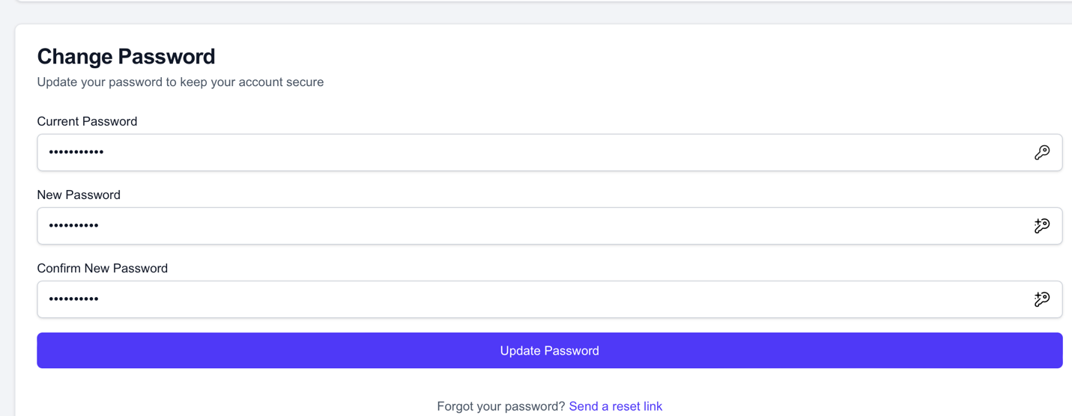
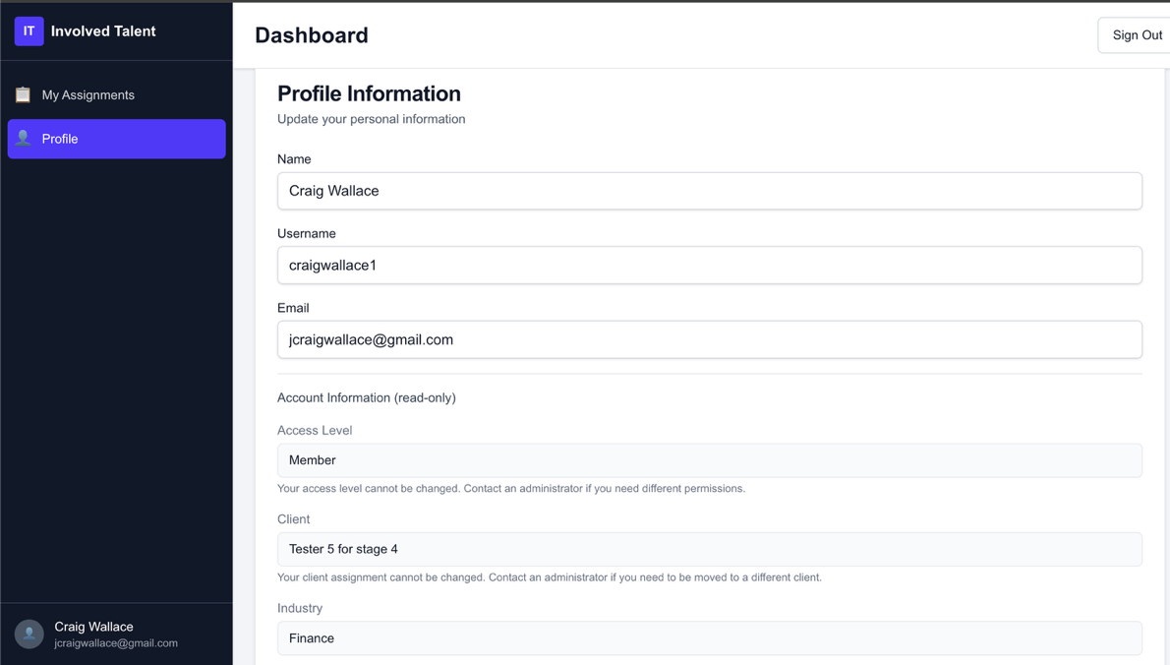

Hmmm… I like this, but how will the workflow work when we are done with survey responses? Could not fully test because of incomplete data due to not being able to assign all assessments (i.e., can’t assign multiple people for a 360).
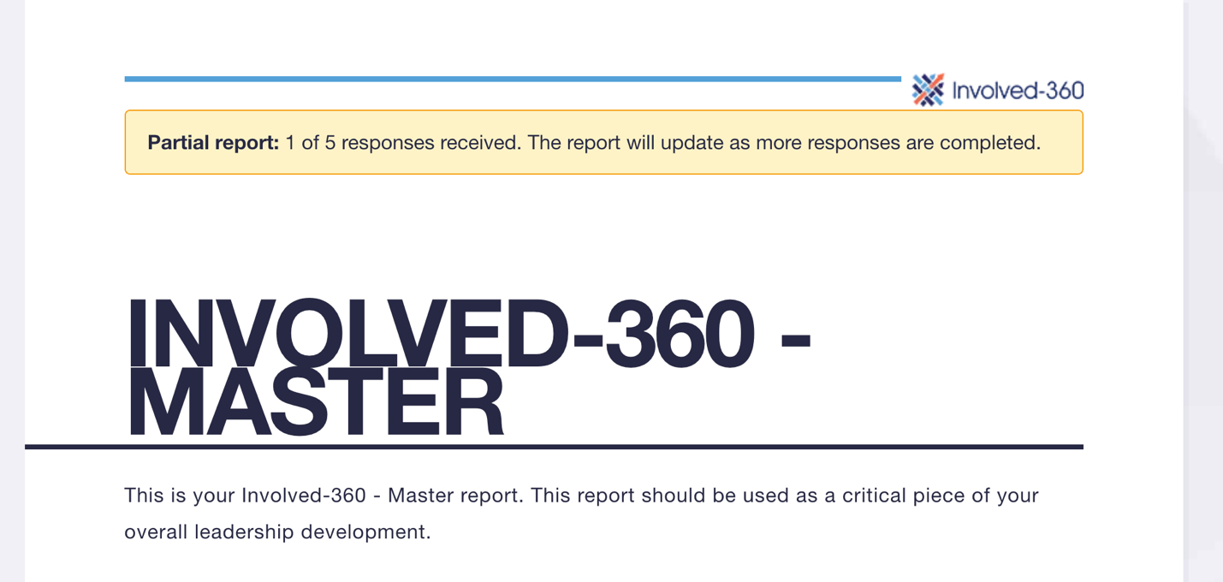

- How do I add edit assignments – I see I can add one to an existing survey (Kudos), but how do I edit … how do I extend a deadline for an assignment or delete an assignment? I need that functionality.
- 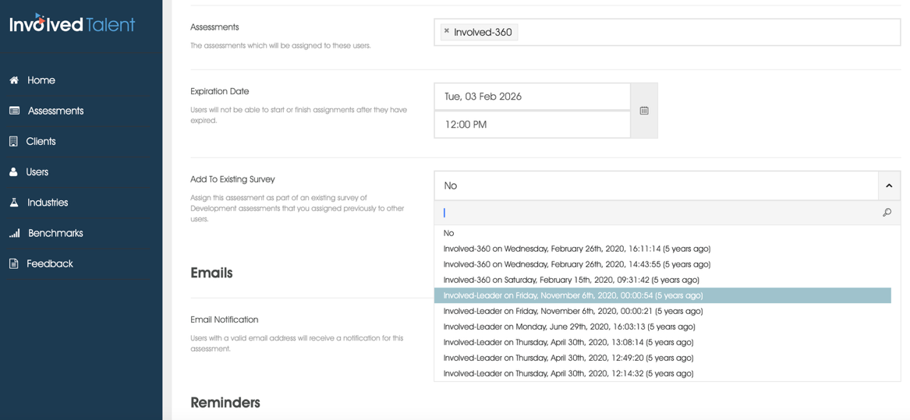
- EDIT LIKE ON THIS PAGE: - Still pending
- 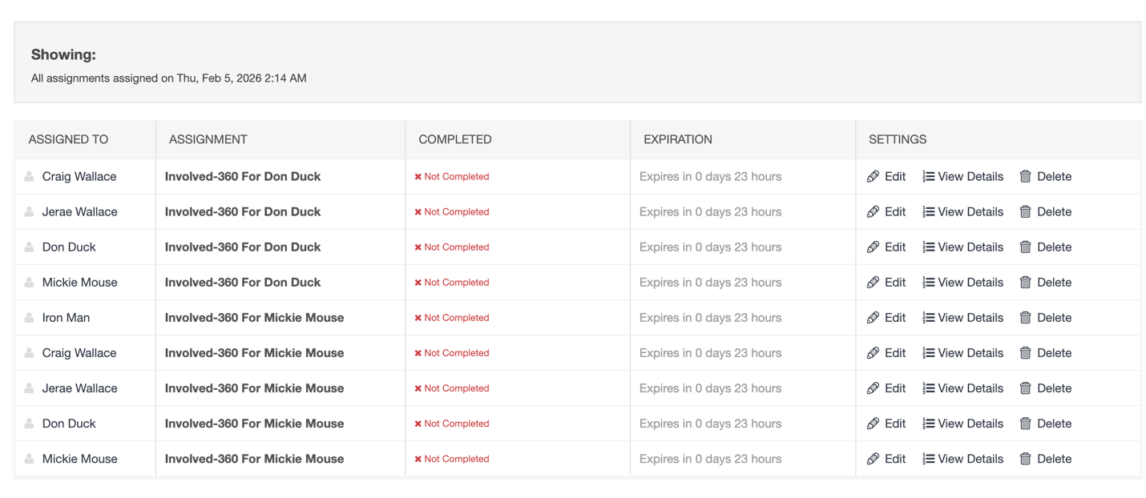

This is a great feature, but how do I know they are ready? Do I still have to download them individually? Or is there a zipped folder I can download? – Still pending
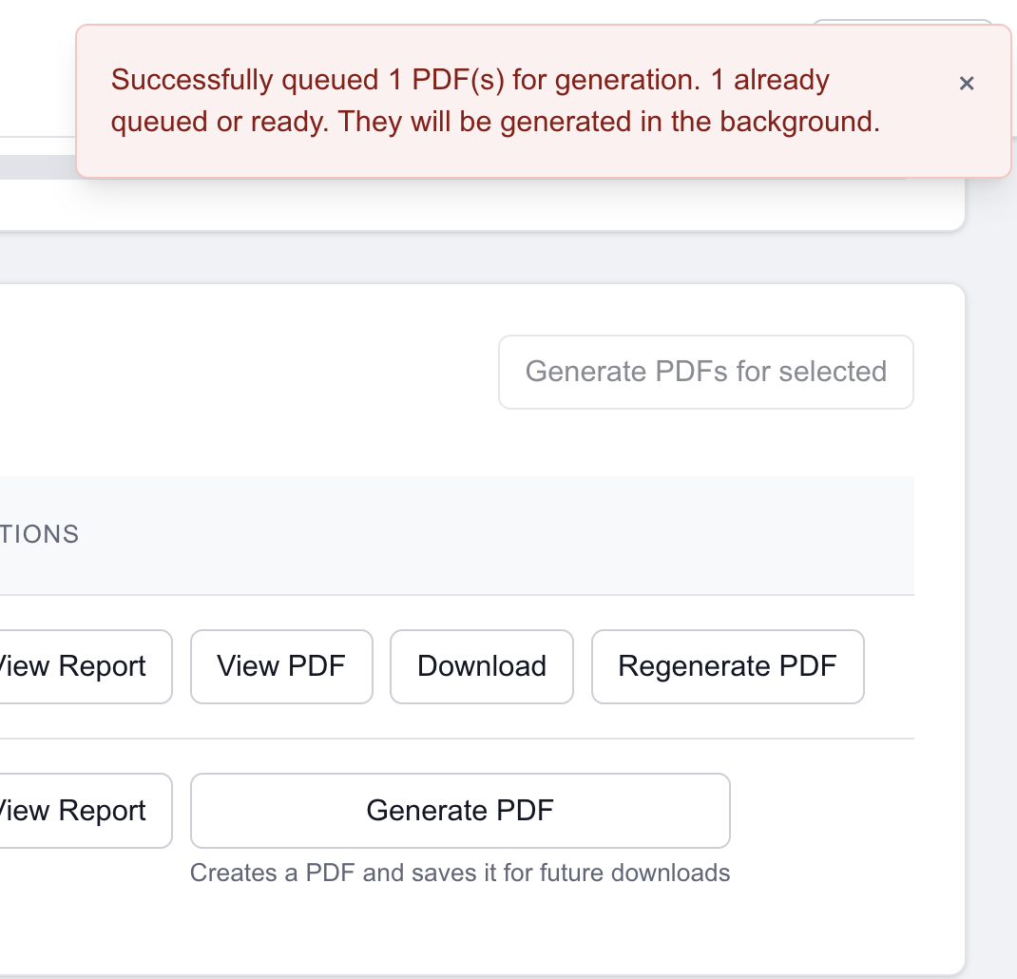

Why can’t I add this person for this rating? – Still pending
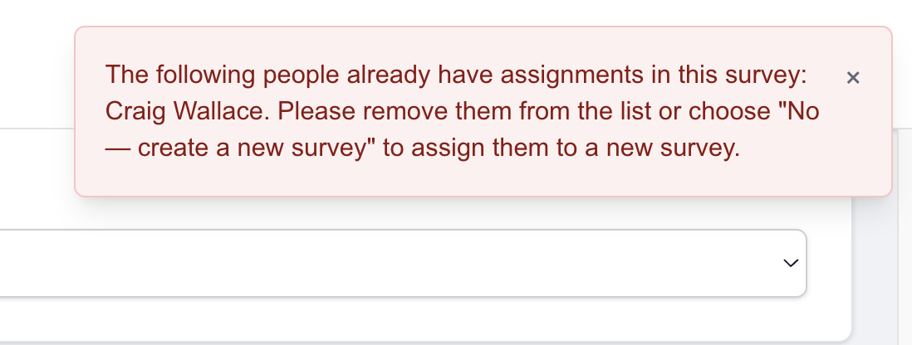

Can’t delete assessments:
